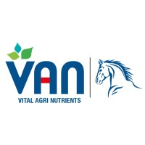

QCL-FRM-6.08
REV#00
REV. DATE: 07-02-2023

QC LAB
RAW MATERIAL
QUA LITY CHECK REPORT
Glassware’s

Material: Polypropylene Flask 100ml Vender: Inam Scientific Store
Date arrived :31-07-24 Quantity: 6
SR/GRN No: 9622 LOT# NA

S.NO | Descriptions | Parameters | Test result
 | Grade Material | Yes/NO | Yes
 | Calibration Certificates | N/A | Yes
 | Capacity | As per SPD | 6
4 | Certificate of analysis | N/A | Yes
5. | Receiving condition (any breakage) | Y/N | NO
6. | MSDS | Y/S | NO

Accepted  Rejected

If rejected give reason:

____________ _____________ _____________
QC QCM P.M

